

|  |  |
| --- | --- |
| **Course Code** | INT246 |
| **Project Name** | LPU Students Performance Using Fuzzy-Logic |
| **Section** | RKEM62 |
| **Submitted To** | Usha Mittal |
| **Submitted by (roll no)** | 27,28,29 |
| **Registration Numbers** | ( ) , (11613232 ) , (11614664) |

**Fuzzy Logic Based expert System For Student Grading System For LPU**

**Introduction:**

The Introduction part is reports on the design and development of an expert fuzzy classification

Scoring for grading student writing samples. The growing use of written response tests in the education sector provides fertile domain areas for the application of soft computing and expert systems technology. The main function of the expert fuzzy classification scoring system is to support teachers in the evaluation of student writing samples by providing them with a uniform framework for generating ratings based on the consistent application of scoring rubics.

The system has been tested using actual student response data. A controlled experiment demonstrated that teachers using the expert fuzzy classification scoring system can make assessments in les time and with a level of accuracy comparable to the best teachers graders.

The fuzzy classification techniques as a basis for constructing rule-based scoring models that can encapsulate knowledge needed for consistent scoring results. This increased consistency in the application of the scoring rubics allows for more valid individual and group assessment.

**Methods For calculating GPA Of Student In LPU:**

|  |  |  |
| --- | --- | --- |
| **Grade[Condition]** | **Percentage-Value** | **Grade-Value** |
| **O[Excellent]** | **90-100%** | **10** |
| **A+[Very Good]** | **85-89%** | **9** |
| **A[Good]** | **80-84%** | **8** |
| **B+[Above Average]** | **70-79%** | **7** |
| **B[Average]** | **60-69%** | **6** |
| **C[Fair]** | **50-59%** | **5** |
| **D[Pass]** | **40-49%** | **4** |
| **E[Poor}** | **30-39%** | **0** |
| **F[Fail]** | **0-29%** | **0** |
| **G[Backlog]** | **0-29%** | **0** |
| **I[Result Incomplete]** | **0%** | **0** |

**E.g :-**

|  |  |  |  |
| --- | --- | --- | --- |
| **Subject_Code** | **Credits** | **Grade_Obtain** | **Credit * Grade_val** |
| **CSE306** | **3** | **O** | **3*10** |
| **CSE307** | **1** | **O** | **1*10** |
| **CSE3010** | **3** | **A+** | **3*9** |
| **CSE316** | **3** | **A+** | **3*9** |
| **CSE322** | **3** | **O** | **3*10** |
| **CSE325** | **1** | **O** | **1*10** |
| **CSE408** | **3** | **O** | **3*10** |
| **MTH302** | **3** | **A+** | **3*9** |
| **PEV106** | **3** | **A+** | **3*9** |
| **Total** | **23** | **total** | **218** |

**GPA = Total Grade_Value / Total Credits**

GPA=218/23

GPA=9.47826087

GPA=9.48(Approx)

=>This Value Near to 10 (which comes Under Excellent )

=>Student is Excellent

**Algorithm Steps Of Fuzzy Logic:**

* Define linguistic variables and terms(Excellent,Very_good, Good, etc)
* Construct membership Function for them.
* Construct knowledge base of rules.
* Convert crisp data intofuzzy data sets using membership function(Fuzzification).
* Evaluate results in the rule Base(Inference Engine).
* Combine rules from each rule(inference Engine).
* Convert output data into non-fuzzy values(defuzzification).

**Flow-Chart:**

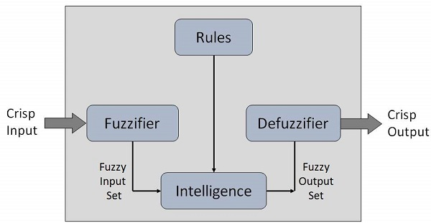

**Conclusion:**

Fuzzy systems, including fuzzy logic and fuzzy set theory, provide a rich and meaningful addition to standard logic. The mathematics generated by these theories is consistent, and fuzzy logic may be a generalization of classic logic. The applications which may be generated from or adapted to fuzzy logic are wide-ranging, and provide the opportunity for modeling of conditions which are inherently imprecisely defined, despite the concerns of classical logicians. Many systems may be modeled, simulated, and even replicated with the help of fuzzy systems, not the least of which is human reasoning itself.

* Ability to capture and preserve irreplaceable human experience.
* Ability to develop a system more consistent than human experts.
* Solutions can be developed faster than human experts.
* Beneficial for real-time applications
* Linear and nonlinear control.
* Make calculation process easy for teachers ,university staff etc.
* Evaluate Student performance in better way.